**WHAT IS DATA SCIENCE?**

Advances in technology have filled our world with information. This digital economy can present challenges, but also opportunities to improve strategic thinking in health care and several other industries. The **data science profession plays an essential role** by finding insights from big data that help businesses make strategic decisions and optimize outcomes.

Data scientists uses computer science and mathematical and statistical concepts to analyze massive amounts of information. Professionals are also experienced with several programming languages like Python, R, SQL and SAS. The field has exciting applications for several academic areas and nearly every sector of industry.

**WHAT DOES A DATA SCIENTIST DO?**

Drawing insights from massive data is a complex process that involves the following:

* Carefully ask probing questions to identify a business problem and an approach to solving it.
* Responsible data stewardship: A successful data scientist must be able to implement best practices for data management and stewardship, as well as conduct research in an ethical manner that maintains data security and privacy.
* Acquire data from sources such as databases, online repositories and webservers.
* Clean up data by addressing missing values, inconsistent data types, and other issues before it is mapped for transmission. This skill—data wrangling—is key to be an effective data scientist.
* Perform exploratory analysis to determine variables for model development.
* Select the data model for your analysis.
* Apply methodologies such as machine learning, artificial intelligence and deep learning.
* Communicate your findings with data visualization so that less technical partners will understand the business implications of your work.

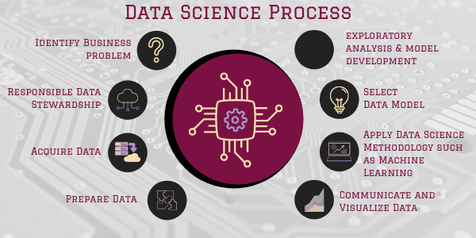

[**Learn the skills and methods you need to enjoy a rewarding career in data science with Meharry.**](https://sacsmeharry.org/sacs/requestinformation/)

**DATA SCIENCE CAREER TRENDS**

The need to draw important insights from massive data has made data science an in-demand technology profession. In fact, [**Glassdoor**](https://www.glassdoor.com/List/Best-Jobs-in-America-LST_KQ0,20.htm) listed data scientist third on its list of 50 Best Jobs in America for 2020. Future projections remain bright as the number of jobs [**should increase by 28% by 2026**](https://www.datanami.com/2020/11/16/why-data-science-is-still-a-top-job/#:~:text=The%20U.S.%20Bureau%20of%20Labor,grow%20about%2028%25%20through%202026.).

Additionally, data science has expanded its influence outside of tech to nearly every industry. Today, some of the top industries with demand for data science include [**health care, telecommunications, e-commerce and grocer companies, finance, and cybersecurity**](https://www.linkedin.com/pulse/top-industries-hiring-machine-learning-data-science-2020-greg-olsen/?articleId=6689938934601973760).

Compensation is another positive sign for prospective data scientists. [**The average data scientist salary of $114,012 follows in line with the demand for professionals.**](https://sacsmeharry.org/blog/what-is-a-typical-data-scientist-salary/)  That pay should increase in the future, especially for those with more experience and expertise.